URL: https://adityabirlahospital.com/doctors/rheumatologist-in-pune
Meta Title: Best Rheumatologists In Pimpri-Chinchwad, Pune | ABMH
Meta Description: Find the best rheumatologists in Pimpri, Pune at ABMH. Expert care, advanced treatment, and personalized plans for joint and autoimmune conditions. Book now!
Home / Doctors / Rheumatologist
Best Rheumatologist in Pimpri-Chinchwad Pune
A rheumatologist is a medical expert who diagnoses and treats conditions affecting the joints, muscles, and connective tissues. If you're experiencing persistent pain, swelling, or mobility issues, consulting a rheumatology specialist can help you find relief and improve your quality of life.
Our Team of the Top Rheumatologists in Pune
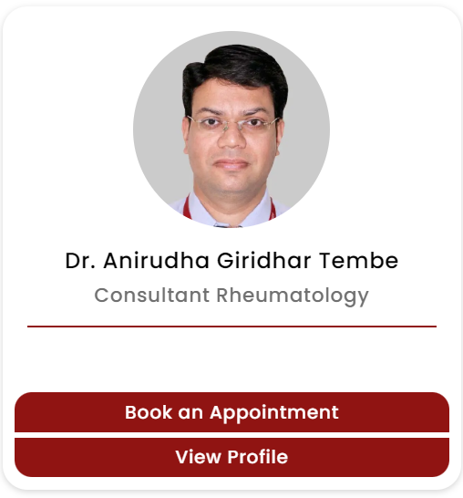
Joint pain, stiffness, or autoimmune conditions can significantly impact your quality of life. At our hospital, we offer access to some of the best rheumatologists in Pimpri Chinchwad, Pune, specializing in diagnosing and managing a wide range of rheumatic diseases with personalized care.
What Our Vascular Surgeons Specialise In:
- Peripheral Artery Disease (PAD) Management
- Varicose and Spider Vein Treatments
- Aneurysm Repair (Including Abdominal Aortic Aneurysms)
- Carotid Artery Surgery to Prevent Stroke
- Deep Vein Thrombosis (DVT) Treatment
- Dialysis Access Surgery (AV Fistula/Graft Creation)
- Endovascular Procedures and Minimally Invasive Surgeries
- Vascular Bypass Surgery
- Treatment for Chronic Limb Ischemia
- Management of Non-Healing Wounds and Vascular Ulcers
- Vascular Trauma and Emergency Care

How to Find the Top Rheumatology Doctors Near Me in Pune?
If you're searching for the best rheumatologist near you, our rheumatology hospital in Pimpri Pune is home to top specialists and advanced facilities. We are committed to providing personalized care and the most effective treatment plans for every patient.
Nearby Locations:
Hinjewadi, Wakad, Baner, Aundh, Pimple Saudagar, Bhosari, Chinchwad Gaon, Tathawade and Nigdi, PCMC, Pimpri, Ravet, Moshi, and Chakan


